**PROPOSAL & SCOPE OF WORK FOR**

**Proposal and Quotation for E-Commerce Website Development Services**

**By**



**Veloxn Private Limited**

**01, September 2025**

**Statement of Confidentiality**

**This document is proprietary to Veloxn Private Limited This document is distributed with the understanding that it will be not be disclosed or used, in whole or part, for any other purpose than for what it is intended, without the prior written consent of Veloxn Private Limited**

Contents

1) PROJECT OBJECTIVE 3

2) VELOXN PRIVATE LIMITED PROPOSAL 3

3) TOOLS & TECHNIUES USED 3

4) SCOPE OF WORK (SOW) & SERVICE DELIVERABLES 3

SOW for Website Design & Development: 3

5) COST & TIME FRAME TO COMPLETE THE WEBSITE 24

6) SCHEDULE FOR COMPLETION 26

7) QUALITY CONTROL METHODS 26

8) POST-IMPLEMENTATION SUPPORT 27

9) TEAM FOR THIS PROJECT 27

10) TERMS & CONDITIONS 27

11) CONTRACT AGREEMENT 28

Assurances 28

## PROJECT OBJECTIVE

As you are looking for E-Commerce Website Development Services.

## VELOXN PRIVATE LIMITED PROPOSAL

VELOXN PRIVATE LIMITED will provide its technical support at the best cost-effective and competitive rates.

The role of VELOXN PRIVATE LIMITED will be as follows:

1. Understanding the exact requirement of the website.
2. Use its technical know-how and innovative ideas to decide the flow of the site.
3. Deciding the back-end and front-end technologist to be used.
4. Develop and design a professional user-friendly design layout of the web & application.
5. Publish a website on a hosting space (yet to be decided).
6. Efficiently run and implement the company made design for admin control for handling key modules as desired by the client.
7. Provide after sales services like maintenance facilities to ensure proper and smooth functioning of the application designed.

## TOOLS & TECHNIUES USED

For implementing and designing the website following tools and technologies will be used:

**Design Software:** Adobe Creative Cloud Suite (Photoshop, Figma, etc.)

**Front-end Technologies:** HTML, JS, CSS, jQuery, AJAX

**Programming Language** - PHP version 8.x

**MVC Framework** - Laravel Framework

**Database –**MySQL RDBMS

## SCOPE OF WORK (SOW) & SERVICE DELIVERABLES

The proposed website shall be compatible on all the desktop, mobile platforms, screen resolution (responsive) and tablets and will be designed and developed keeping in the exact requirements of the client.

## SOW for Website Design & Development:

The following have to be provided by the client or will be charged as per actual of purchase

|  |  |
| --- | --- |
| **S.N** | **Specification** |
| 1 | Domain |
| 2 | Hosting |
| 3 | cPanel |
| 4 | Data backup module |
| 5 | SSL setup |
| 6 | Security module setup |
| 7 | SMTP (for emails) |
| 8 | SMS gateway |
| 9 | Language converter |
| 10 | Content |
| 11. | Payment Gateway |

**Website Configuration –**

Website frontend UI as required and following features of the existing website, Powerful admin with backend can create and include blog section and insert the required content for the products.

Here are some screens at front end –

1. Introduction screen 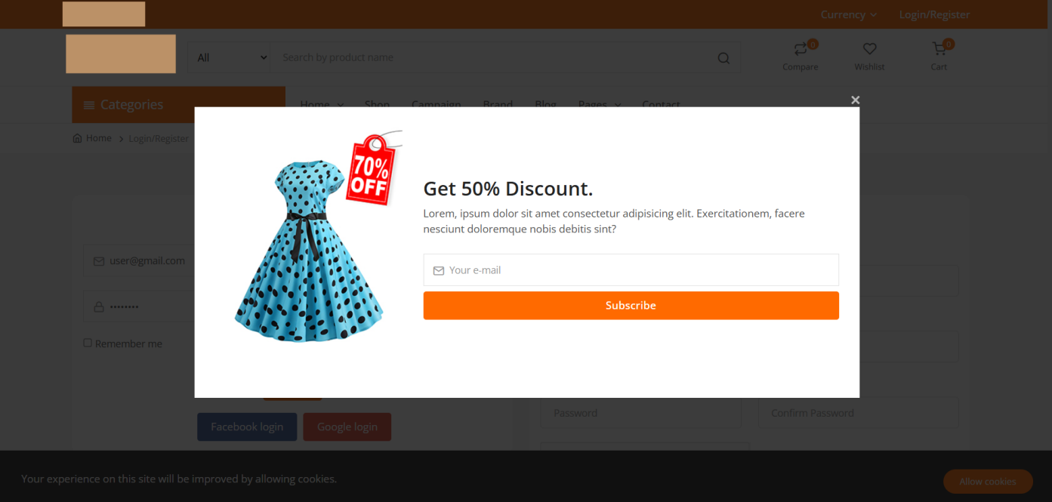
2. Home Screen 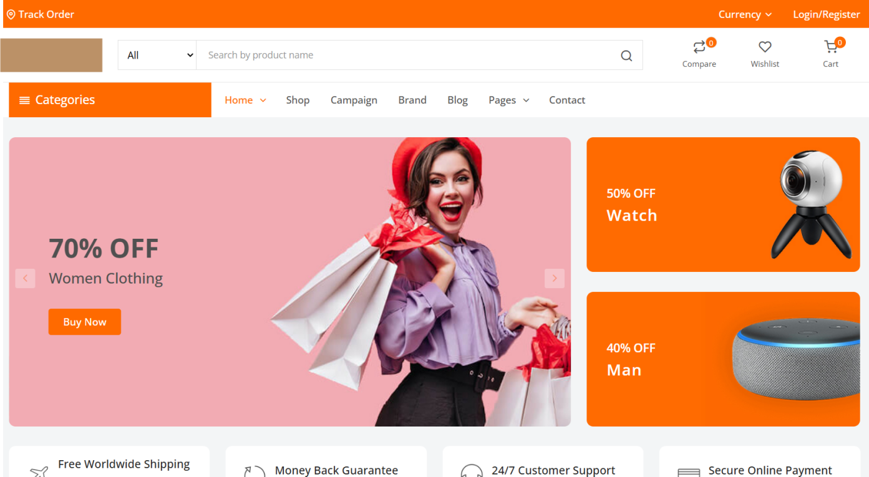 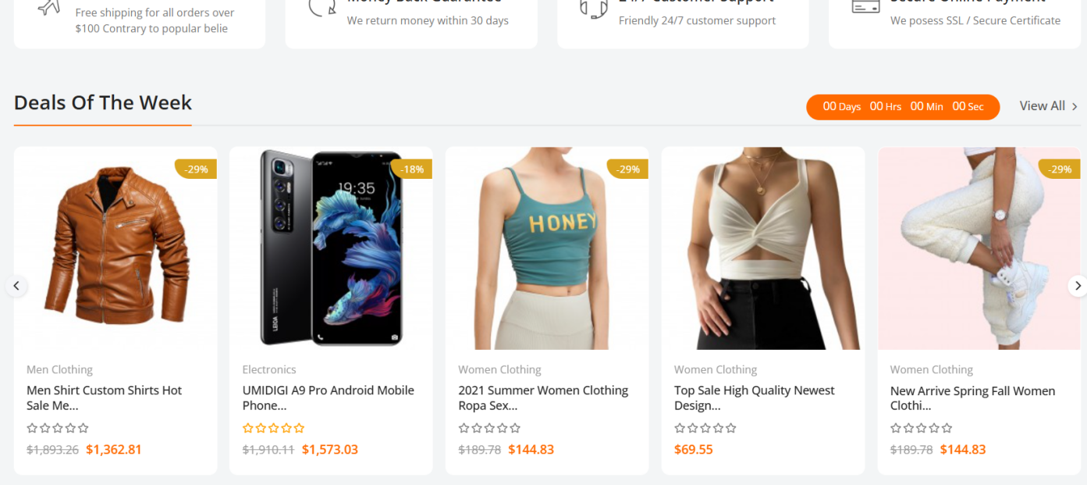  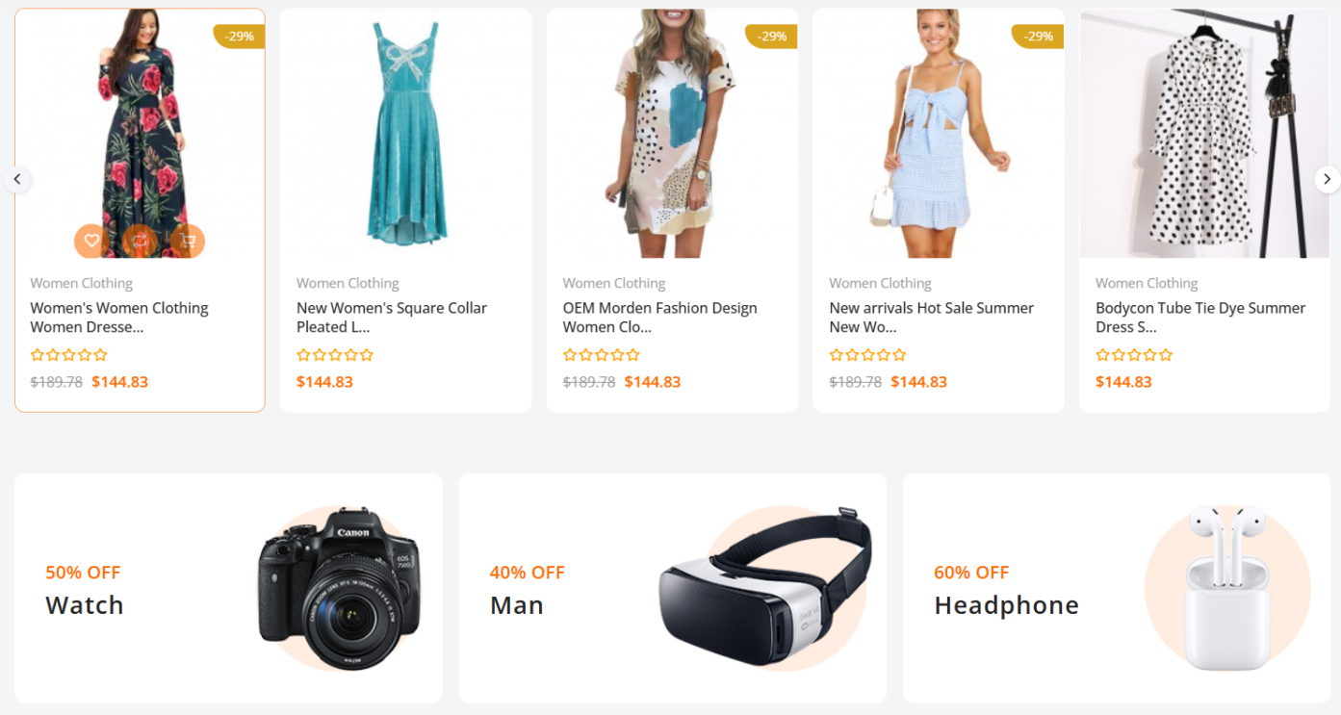 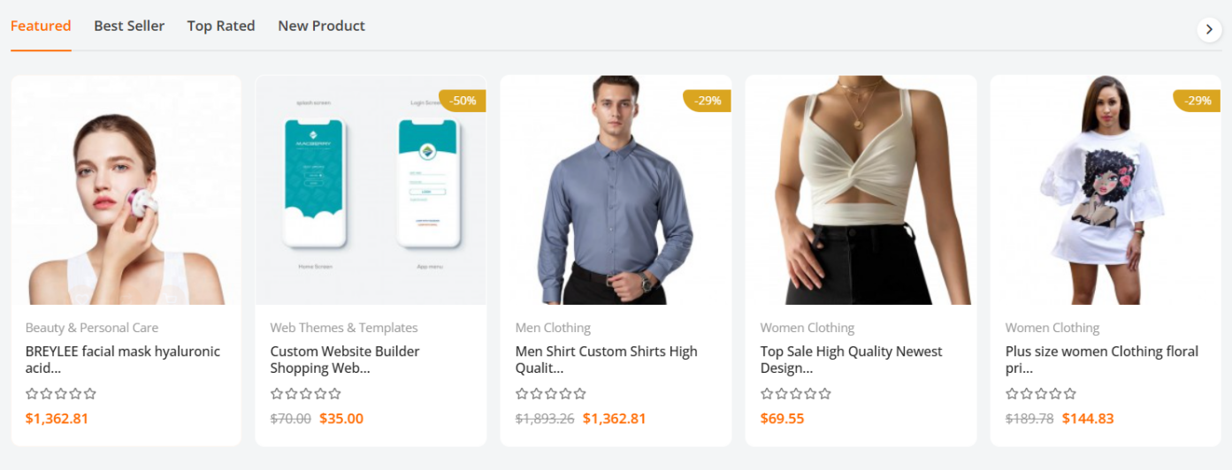 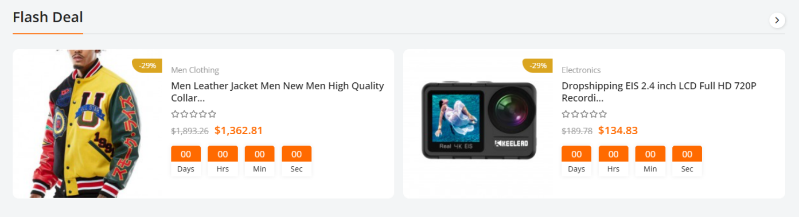 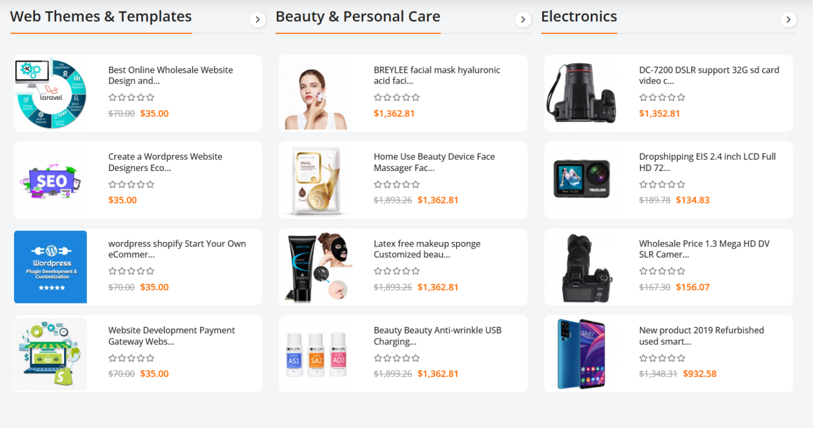    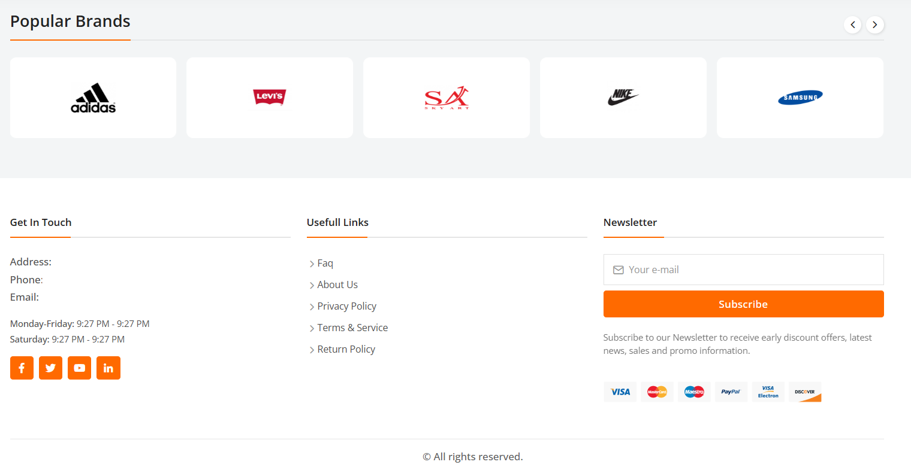
3. Product Page 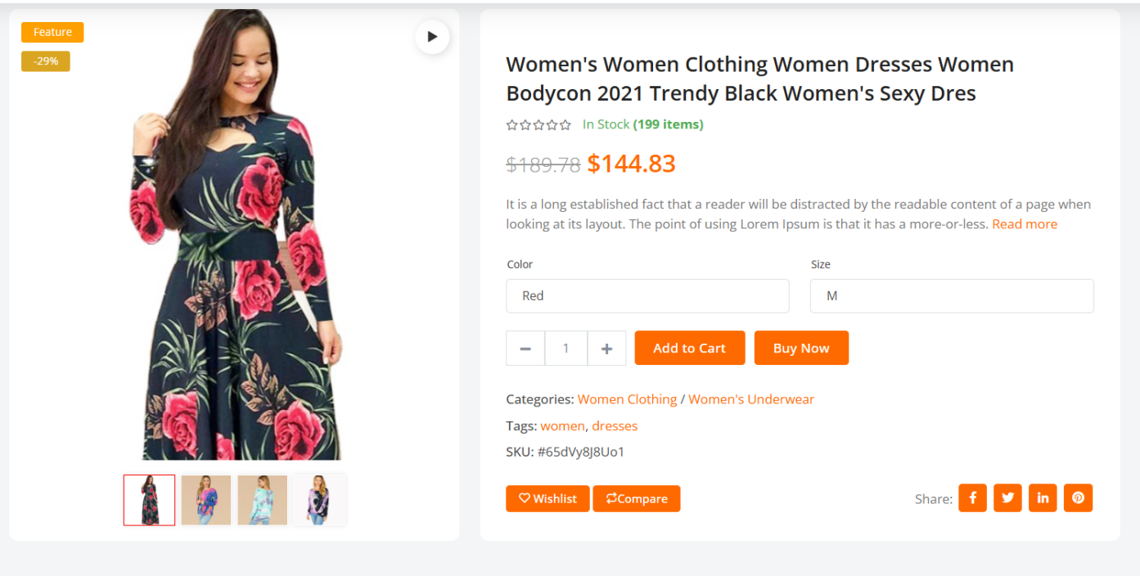 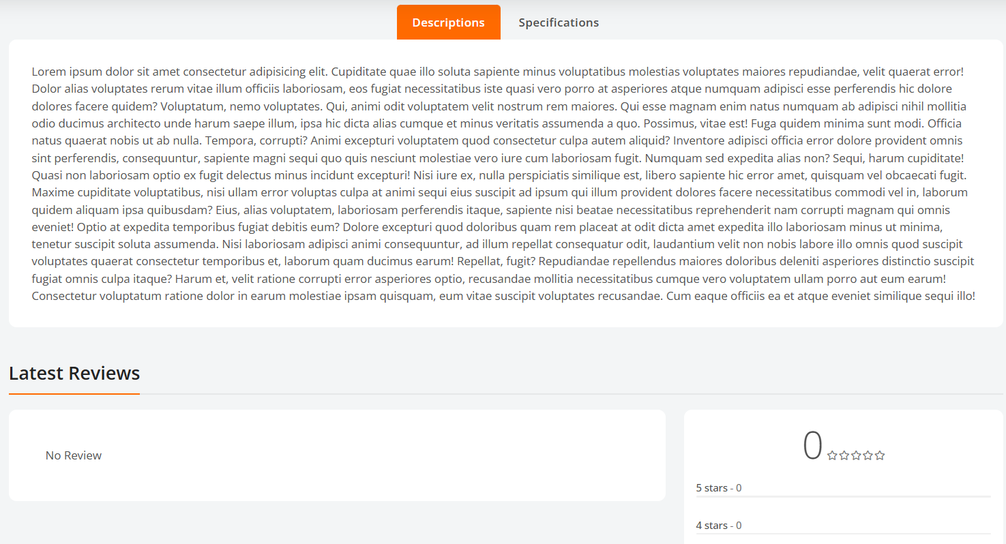 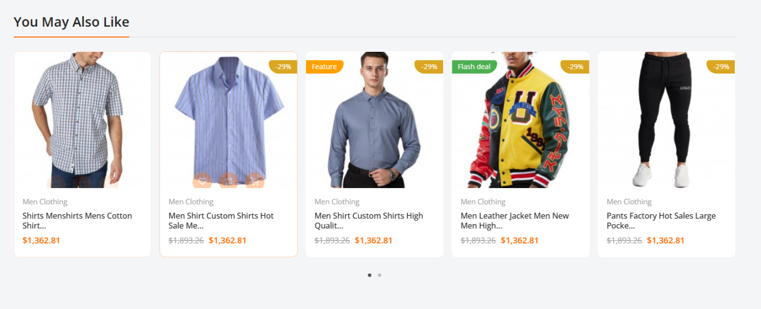
4. Compare products 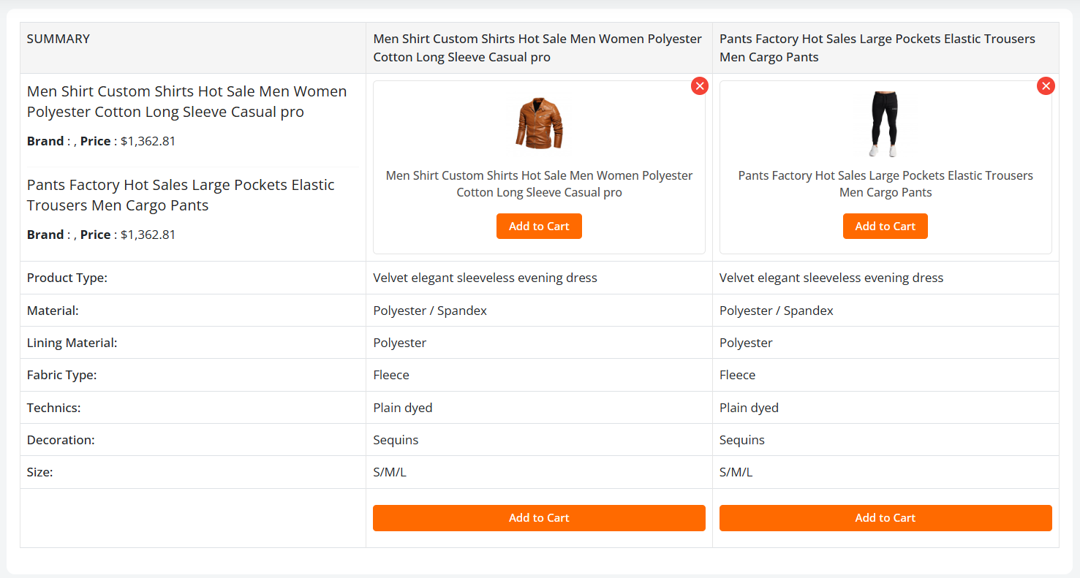
5. Filter Page  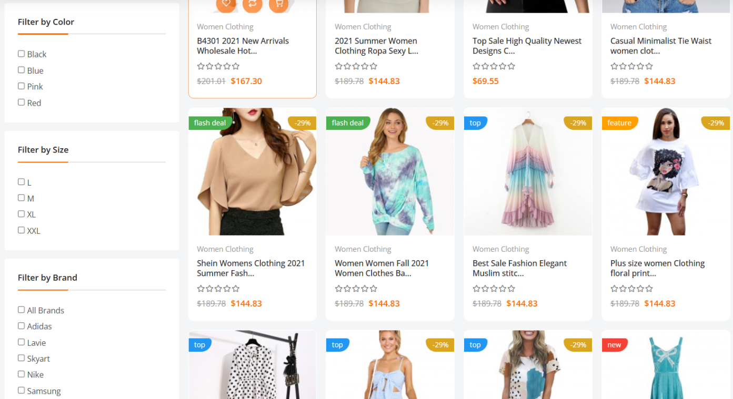
6. **Login page** 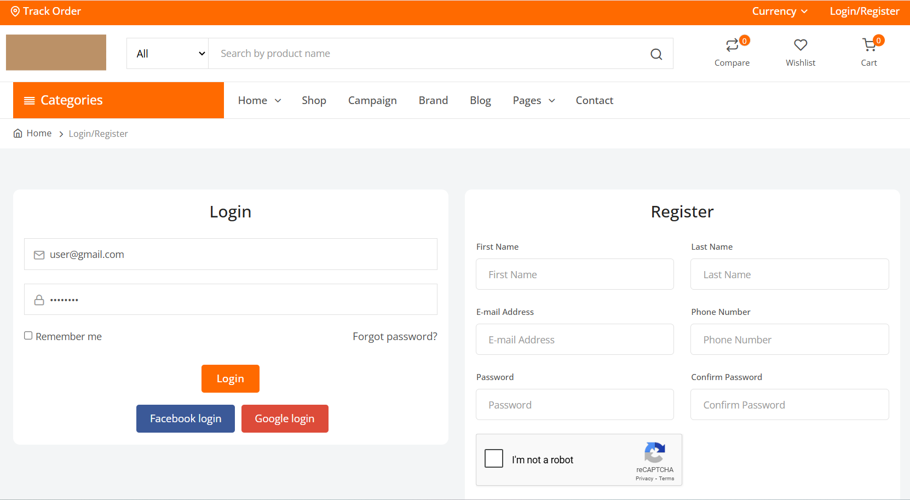
7. **Wish list** 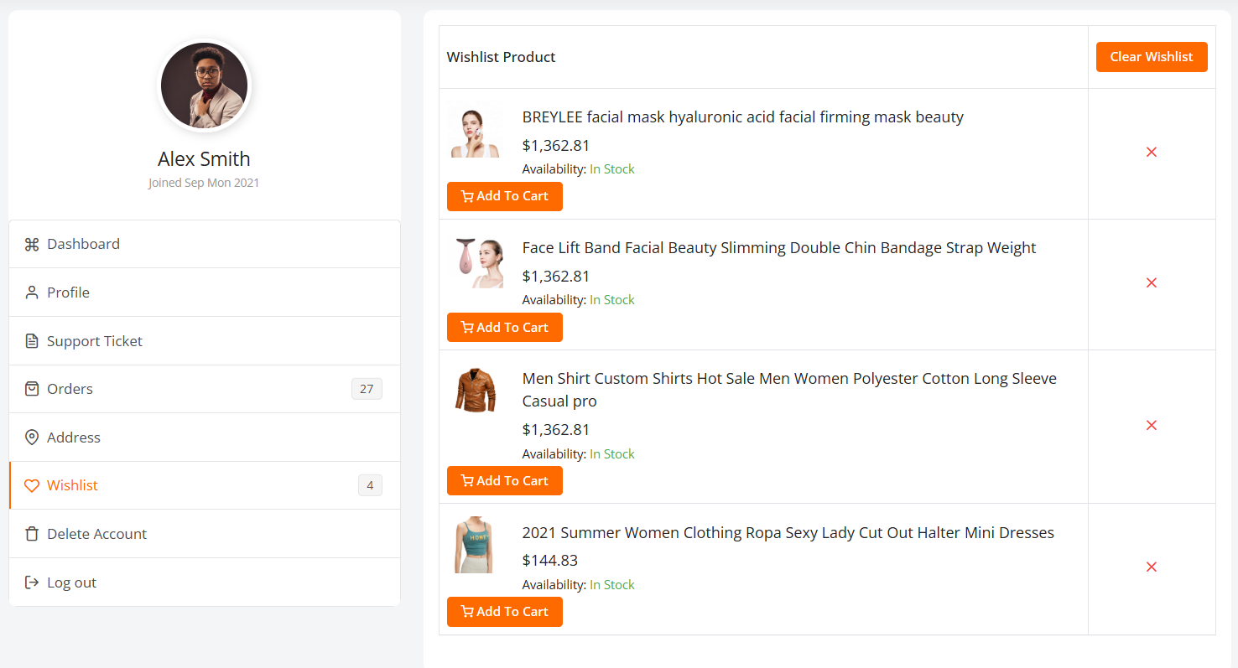
8. Shop 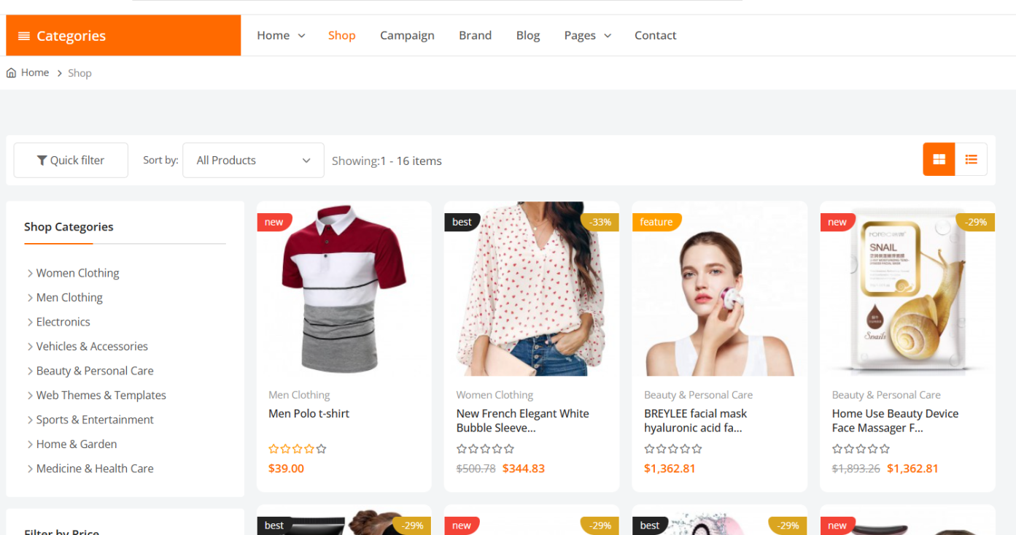
9. Blogs   
10. Blog details page   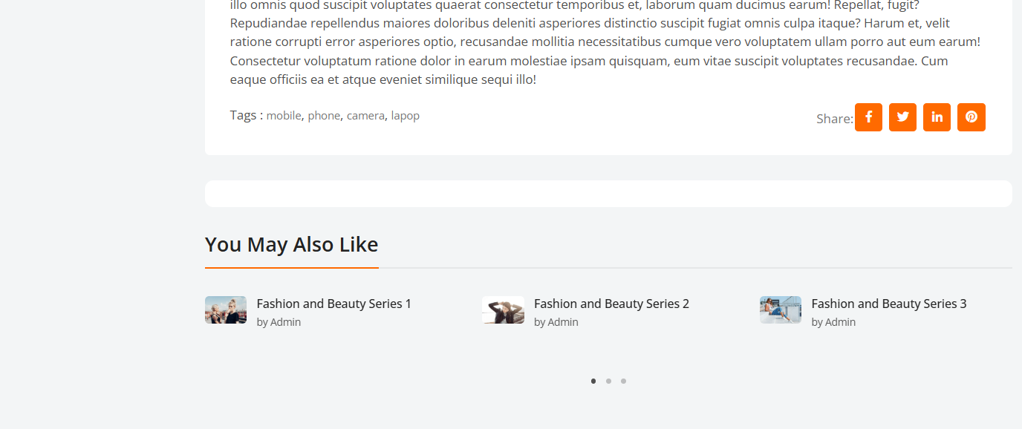
11. Customer Dashboard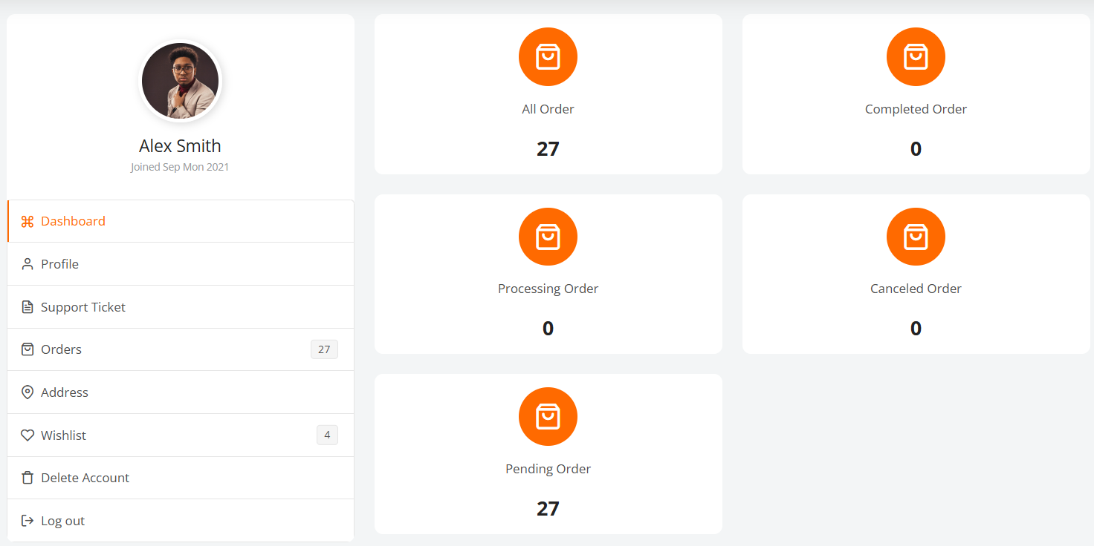
12. Customer profile 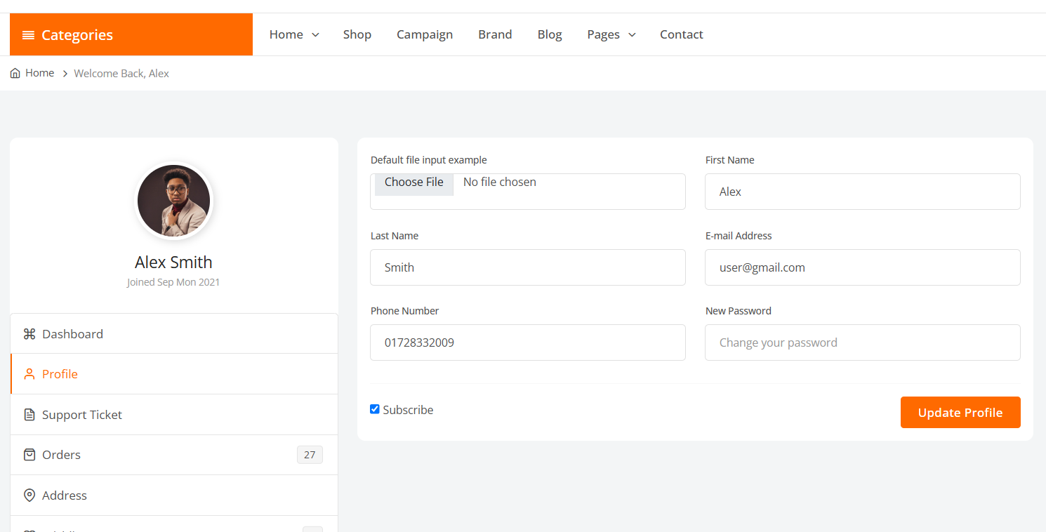
13. Customer support 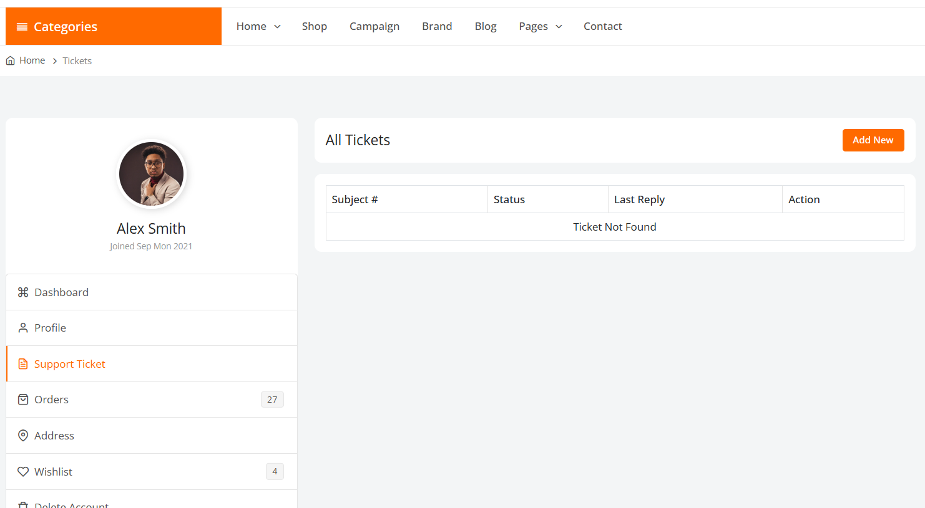
14. Customer orders 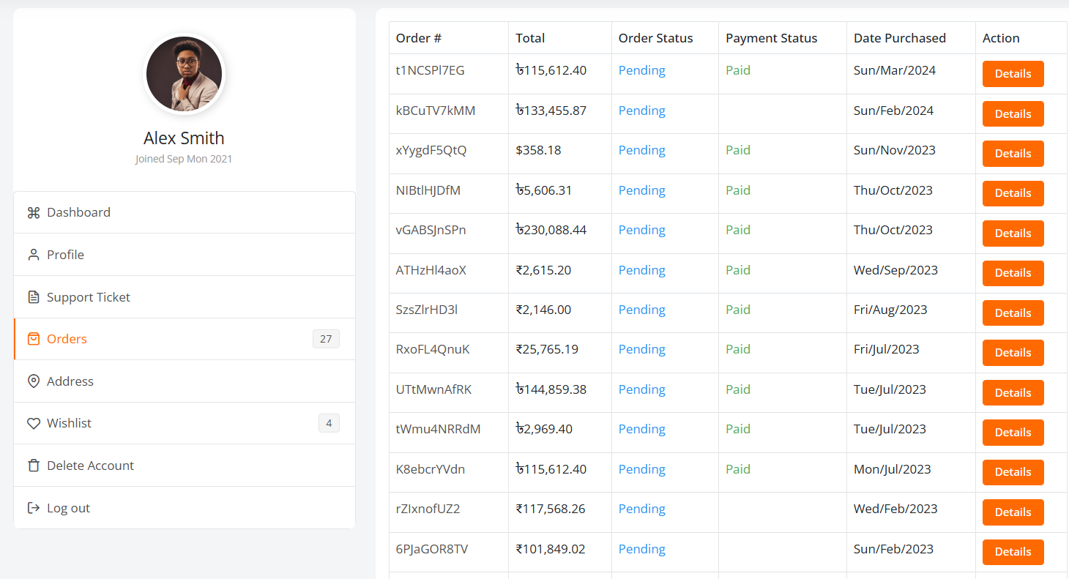
15. Wishlist 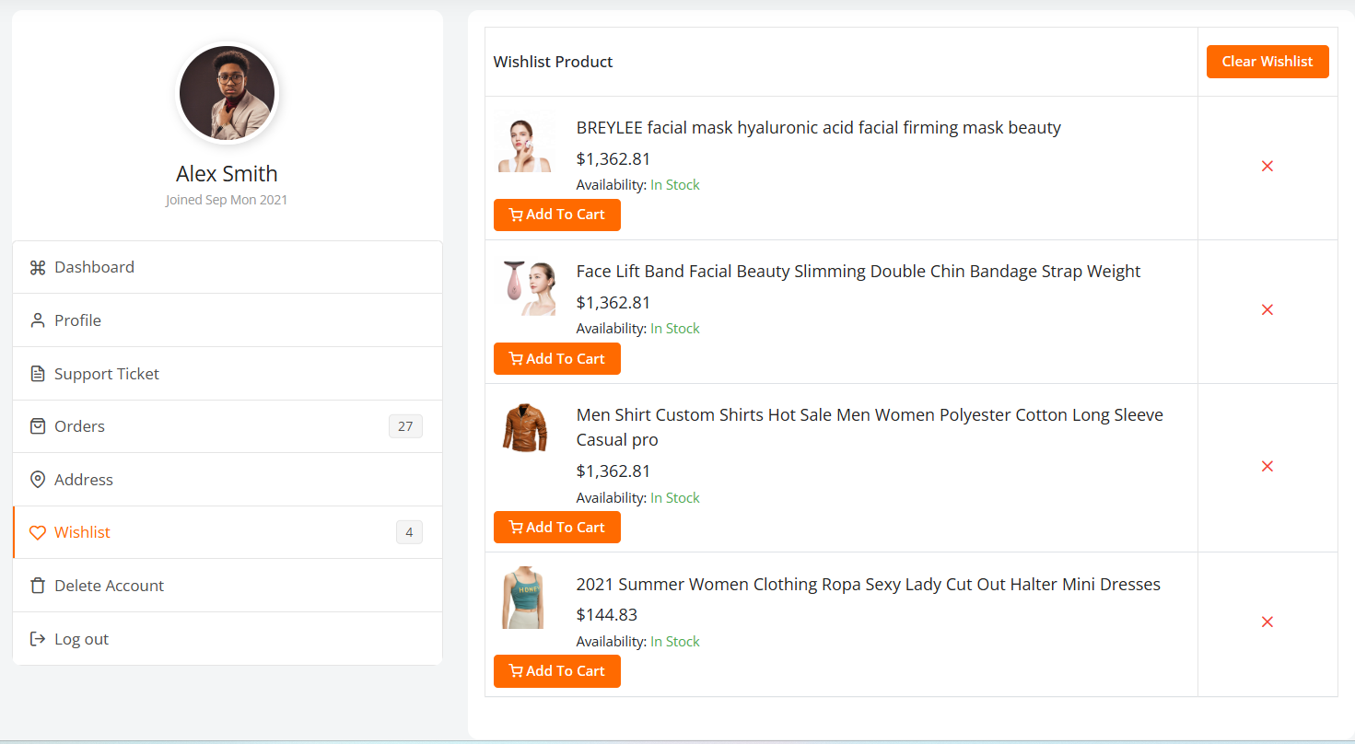

**Admin Logged In** 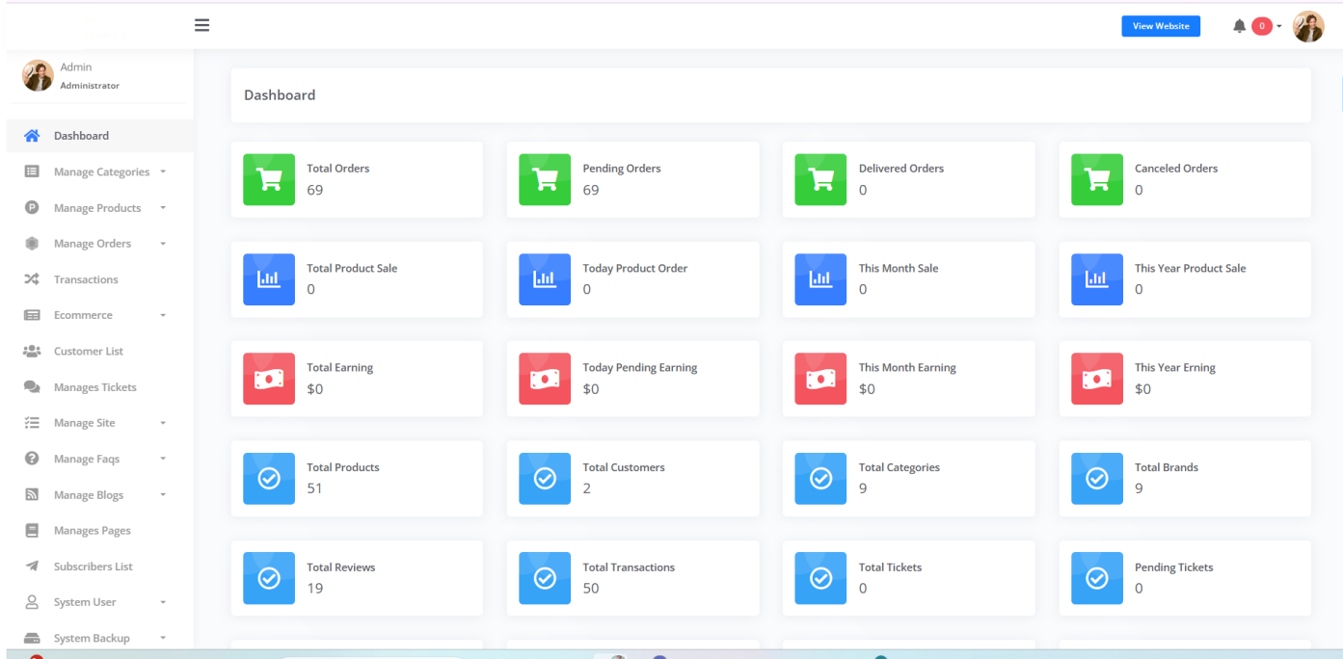 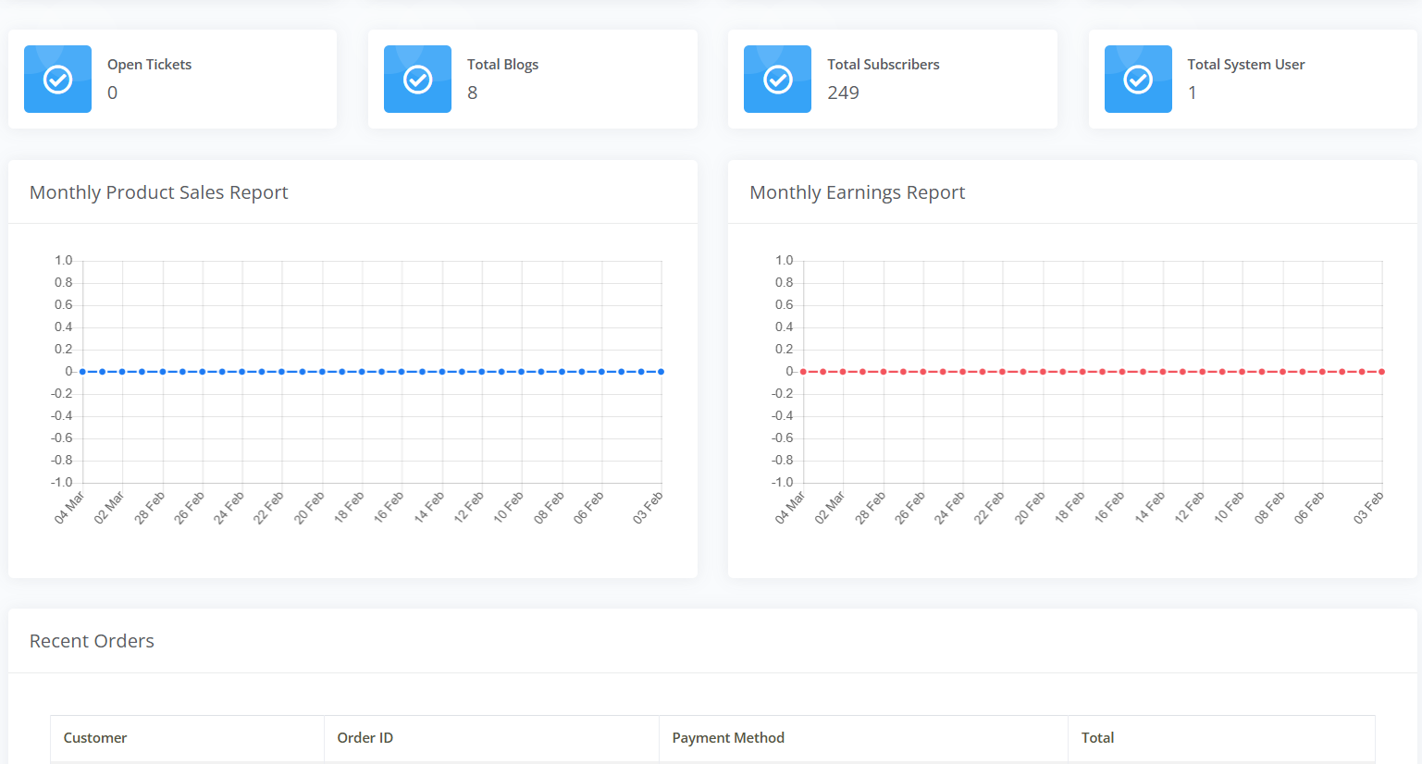 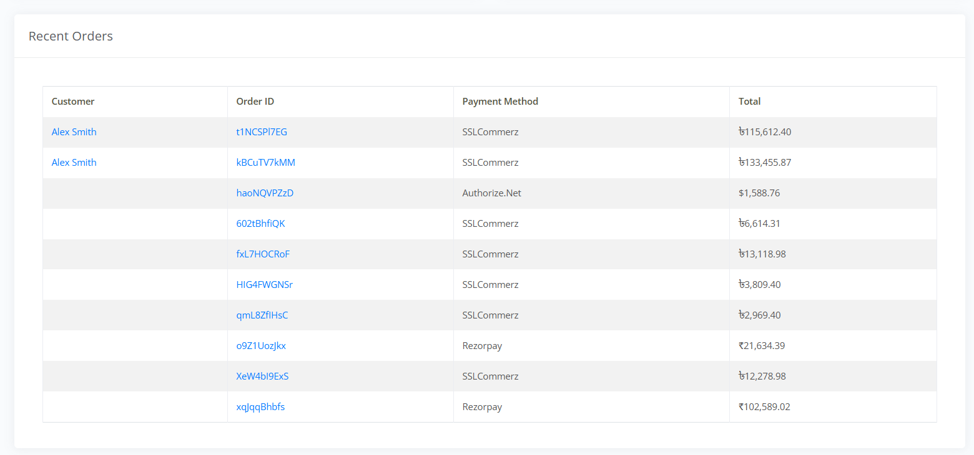

Complete admin modules list is here –

Dashboard

Manage Categories

Categories

Sub categories

Child categories

Manage Products

Brands

Add Product

All Products

Stock Out Products

Campaign Offer

CSV Import & Export

Product Reviews

Manage Orders

All Orders

Pending Orders

Progress Orders

Delivered Orders

Canceled Orders

Transactions

Ecommerce

Set Coupons

Shipping

State Tax

Tax

Currency

Payment

Customer List

Manages Tickets

Manage Site

General Settings

Home Page

Sliders

Services

Visibility

Social Login

Email Settings

SMS Settings

Announcement

Cookies Alert

Maintainance

Sitemap

Language

Manage Faqs

Categories

Faqs

Manage Blogs

Categories

Blogs

Manages Pages

Subscribers List

System User

Role

System User

**Highlighted Features :**

* + Clean and Modern Fronted & Admin Interface.
  + 100% Responsive Design.
  + Physical Product Sale.
  + Digital Product Sale.
  + Affiliate Product Sale.
  + Licence Product Sale.
  + Product Attribute Option.
  + Attribute Wise Product Price.
  + Attribute Wise Product Stock.
  + Multi Currency Support.
  + 13 Payment Method.
  + Guest Checkout Option.
  + State-wise Tax.
  + Currency/Price Separator option with Dot and Comma.
  + Ajax Product Load.
  + CSV Product Upload.
  + CSV Product Export.
  + CSV Order Export.
  + CSV Transactions Export.
  + Bulk Delete Option.
  + Image Lazy Load.
  + Sitemap Generator.
  + Google Adsence.
  + Google Analytics.
  + Google reCaptcha.
  + Facebook Pixel.
  + Facebook Messenger.
  + Database Backup System.
  + System Backup System.
  + Currency Left Or Right Show.
  + Sale Analytic.
  + Coupon Management.
  + Product Variants.
  + RTL Support.
  + Email Notification.
  + SMS Notification.
  + Product Wishlist.
  + Product Compare.
  + Campaign Offer.
  + Flash Deal.
  + Unlimited Color Option.
  + Tax Module.
  + Shipping Module.
  + Maintains Module.
  + Custom CSS Settings.
  + GDPR Cookie Alert.
  + Translate Frontend & Admin Dashboard.
  + Announcement & Popup Module .
  + Support Modern Browser and Cross-browser Compatibility.
  + Video Tutorials.
  + Regular Updates Facilities.
  + Lifetime Free Update.
  + Premium and Quick Support.
* Payment Method
  + Paypal
  + Stripe
  + Paytm
  + Paystack
  + Mercadopago
  + Authorize.Net
  + Mollie
  + Razorpay
  + Flutterwave
  + SSLcommerz
  + Cash On Delivery
  + Bank Transfer
  + PayTabs
* Admin Features :
  + 100% Secure Admin Dashboard.
  + Categories Management.
  + Product Management.
  + Product Brands Management.
  + Product Attribute Management.
  + Product Create Management.
  + Product Campaign Management.
  + Product CSV Import & Export Management.
  + Product Reviews Management.
  + Product Order Management.
  + Transaction Management.
  + Coupon Management.
  + Shipping Management.
  + Tax Management.
  + Currency Management.
  + Payment Gateway Management.
  + Customer Management.
  + Ticket Management.
  + General Settings Management.
  + Home Page Management.
  + Slider Management.
  + SEO Management.
  + Service Management.
  + Dynamic Color Management.
  + Slider Management.
  + Banner Management.
  + Page Visibility (On/Off section) Management.
  + Social Login Management.
  + Email Management.
  + SMS Management.
  + Announcement Popup Management.
  + Cookie Alert Management.
  + Maintainance Mode Management.
  + Sitemap Management.
  + Language Management.
  + FAQ Management.
  + Blog Management.
  + Dynamic Page Management.
  + Subscribers Management.
  + User Role Permission Management.
* Customer User Features :
  + Clean User Interface.
  + Dashboard Manager.
  + Profile Manager.
  + Tickets Manager.
  + Order Log.
  + Address Manager.
  + Wishlist Manager.
  + Delete Account Option.

## COST & TIME FRAME TO COMPLETE THE WEBSITE

* + Our charged after discounts are **Rs.** 50,000**/+ 1296 GST for doing following activities in 45 Days**
  + Payment is required 50% advance , remaining payment is required in following milestones -
    - 30% when 50% work is done
    - 20% when 100% work is done
  + **200 INR/hour for any changes or any software development.**

The quotation includes:

1. Performing the listed activities
2. Payment of Domain, Hosting, SMS Gateway, Email SMTP etc. is not included in it.

The quotation includes:

1. Designing/Development Cost with complete Content Management System (CMS)website to manage all the areas/pages of the website
2. Free post-launch technical support for 30 days.

***Note: *Hosting, Server Extension, SMS API, EMAIL, Plugin Services,*** *Images, and the content will be provided by the client. If the client is not able to provide the above then VELOXN PRIVATE LIMITED will purchase on behalf of the client.*

*These costs will be billed separately. Further, content writing charges will be extra and will be billed separately. Payment is to be made 100 % in advance. Domain and Hosting are not included in above mentioned charges. Charges for the same will be different.*

*All required services should be purchased by the client only*

***Note: -***

* ***All payments shall be made via cash, cheque or bank deposit, Account Transfer or UPI.***

Bank Details:

**VELOXN PRIVATE LIMITED**

**A/C Number** – 259958439076

**IFSC Code** – INDB0000702

**Bank Name** – Indusind Bank

**UPI ID** veloxnservices@okicici

QR Code – 

**COMPANY:**

Veloxn Private Limited

Iconic Tower C, Corenthum, Sector-62, Noida, UP - 201301, India www.veloxn.com

sales@veloxn.com

91-7292001010

GST - 06AAICV7138B1ZE

## SCHEDULE FOR COMPLETION

We will follow the following schedule for successful development and implementation of the project Phases:

1. Layout Designing
2. Creation of Navigation Architecture
3. Inner Page Designing
4. Dynamic Pages/Section designing with administrative control panel
5. Testing
6. Deployment

## QUALITY CONTROL METHODS

Veloxn Private Limited has its own quality standards which are basically based on ‘Q’ ‘C’ ‘D’ factors i.e., ‘Q’ – Quality, ‘C’ – Cost, ‘D’ – Delivery.

We bring you high-performing, secure, easy-to-use solutions. And we make sure they are simple, flexible, and cost-effective.

## POST-IMPLEMENTATION SUPPORT

After the successful implementation of the project, we will provide necessary technical support when needed free of charge for 30 days. This will also be followed by our routine time-to-time checks. After this period client can opt for AMC for maintenance of the application.

## TEAM FOR THIS PROJECT

|  |  |
| --- | --- |
| **Team Heads** | **Members** |
| Project Manager | 1 |
| Designer/UI Expert | 1 |
| Laravel Expert | 1 |
| Backend Server Expert | 1 |

## TERMS & CONDITIONS

1. **Payment Terms:** The schedule of payments is specified below:
   1. 50 percent of the amount as advance along with the PO.
   2. The balance amount after work completion and before uploading the web application on the default URL.
2. GST as applicable will be charged extra.
3. After completion of the project, VELOXN PRIVATE LIMITED is ready to share the source code of the project with the client (if required).
4. All the data or report inputs preferably in soft copy are to be provided by the client well in advance before starting of the project.
5. In website design, VELOXN PRIVATE LIMITED would use freely available graphics and images. If client insists to have any specific graphics or images, which need to be purchased, client has to pay the additional price for the same.
6. All payments must be made in the name of **Veloxn Private Limited**
7. No refunds would be made once the process is executed or in the process of execution.
8. This proposal is valid for 14 days from the date of the proposal.
9. Disputes, if any subject to New Delhi, India jurisdiction.

## CONTRACT AGREEMENT

## Assurances

**Client and the Contractor agree that all activity pursuant to this contract will be in accordance with all the applicable current federal, state, and local laws, rules, and regulations. IN WITNESS WHEREOF the parties hereto have executed this Agreement by their duly authorized representatives and have caused this Agreement to become effective as of the date above written**.

**Contractor Client – Manish**

**By Veloxn Private Limited By: Sanjay**

**Date: 01, September 2025 Date: 01, September 2025**